Carduinodroid finish line timer

Goal

Carduinodroid is an RC model car used as an attraction at the Open Day event where visitors try to beat a high score for a course. The task is to build a sensitive start/finishing line, measure the time needed using an Arduino, and a display to show the finish time.

Proposed Solution

The idea is to build a custom pressure sensitive plate switch using cardboard and aluminum foil which will be activated when the RC car steps on it. Two sheets of cardboard with aluminum foil taped on one side are placed on top of each other with a cardboard frame used as a spacer. Now a piece of insulated wire is attached onto both the cardboard sheets in such a way such that the bare end of the wire is touching the aluminum sheet. When you press on the center of the cardboard, the two foil sheets will make contact and complete a circuit just like a regular switch.

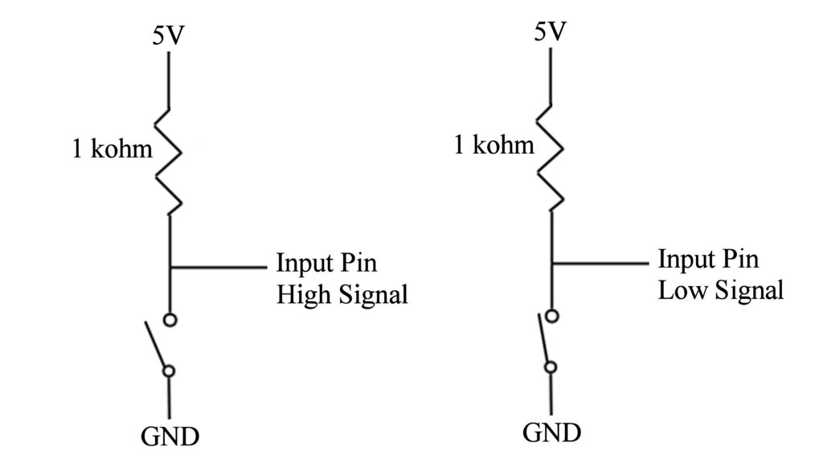

The 1 kohm resistor will act as a pull-up resistor. It will make the input pin read HIGH when the button is not being pressed and when the button is pressed the switch connects the input pin to GND and then read LOW. This signal can be detected using an Arduino and be used to activate a timer. The timer will stop when the RC car steps on to the finish line again. The total time needed can be calculated and displayed onto the LCD display.

Requirements

Cardboard sheets

Aluminum foil

Insulated wire

Breadboard

Arduino UNO

16 x 2 LCD Display

1 kohm resistor

10k ohm potentiometer

220-ohm resistor

hook up wires